Gabe Delgado

08-17-2021

IT FDN 110

Assignment 06

**Functions and Classes**

**Introduction**

This python program manages a “To Do” list through the use of functions and classes.

**Building the Script**

Step 1: Declare variables and constants.

Step 2: Create “Processor” class and develop appropriate functions to be used in script.

Step 3: Create “IO” class and develop appropriate functions to be used in script.

Step 4: Load existing data into dictionary from .txt file.

Step 5: Display menu of choices to user.

Step 6: Create base scripts for options to add new task, remove existing task, save data to file, reload current data in file, and exit the program.

Step 7: Insert relevant functions into each step of the code.

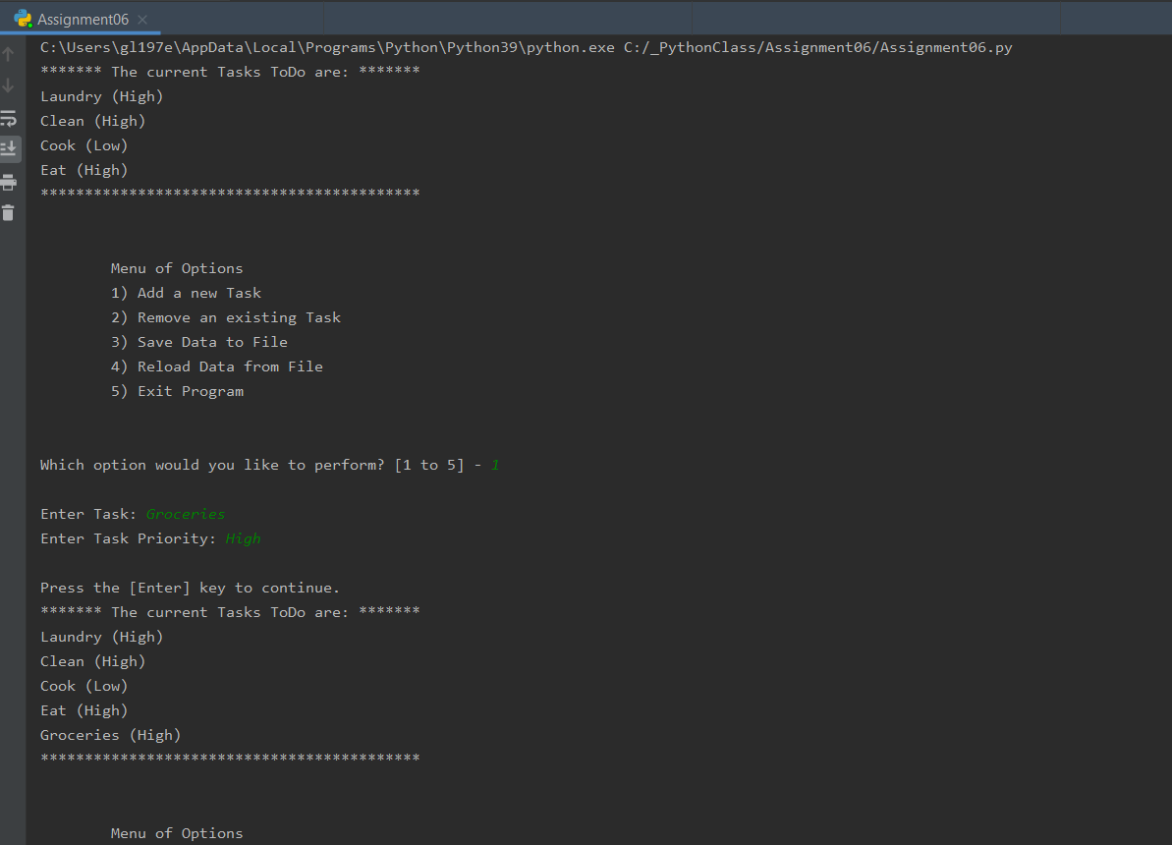

**Figure 2. Program running in PyCharm**

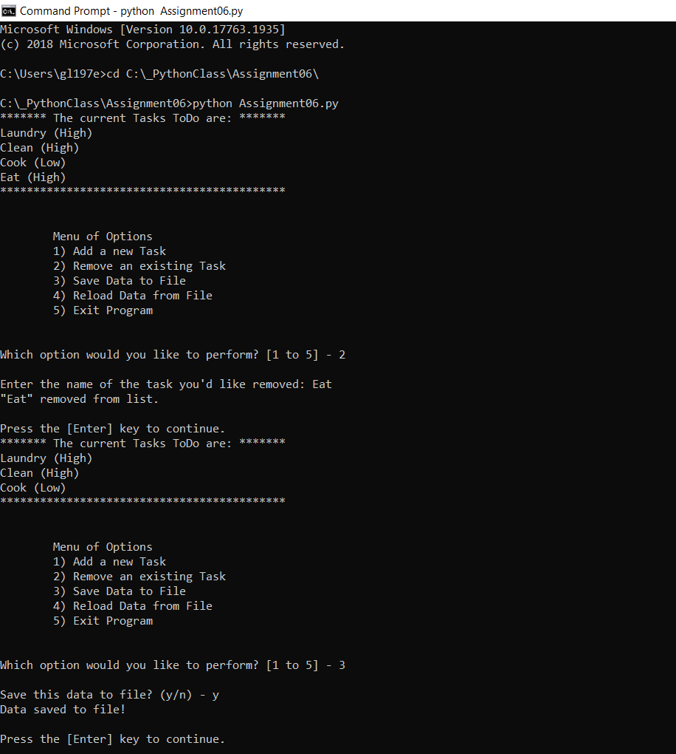

**Figure 3. Program running in command prompt**

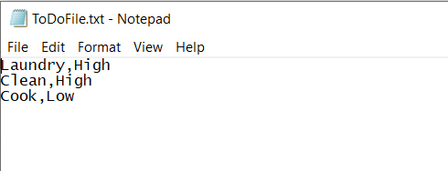

**Figure 4. Text file capturing data**

**Summary**

In this assignment, I learned how to work with functions and classes to organize and simplify a script.